**Procedure Room Camera Setups**

Airway procedures with GlideScope...............................................................................................2

Airway procedures without GlideScope..........................................................................................4

Small area procedures with US........................................................................................................6

Small area procedures without US (category 1)..............................................................................8

Small area procedures without US (category 2)............................................................................10

Large area procedures without US (category 1)............................................................................12

Large area procedures without US (category 2)............................................................................14

**Airway procedures with GlideScope**

* Nasopharyngeal airway
* Oropharyngeal airway with GlideScope

Overhead webcam

Recording cart

GlideScope camera

GlideScope

Workspace

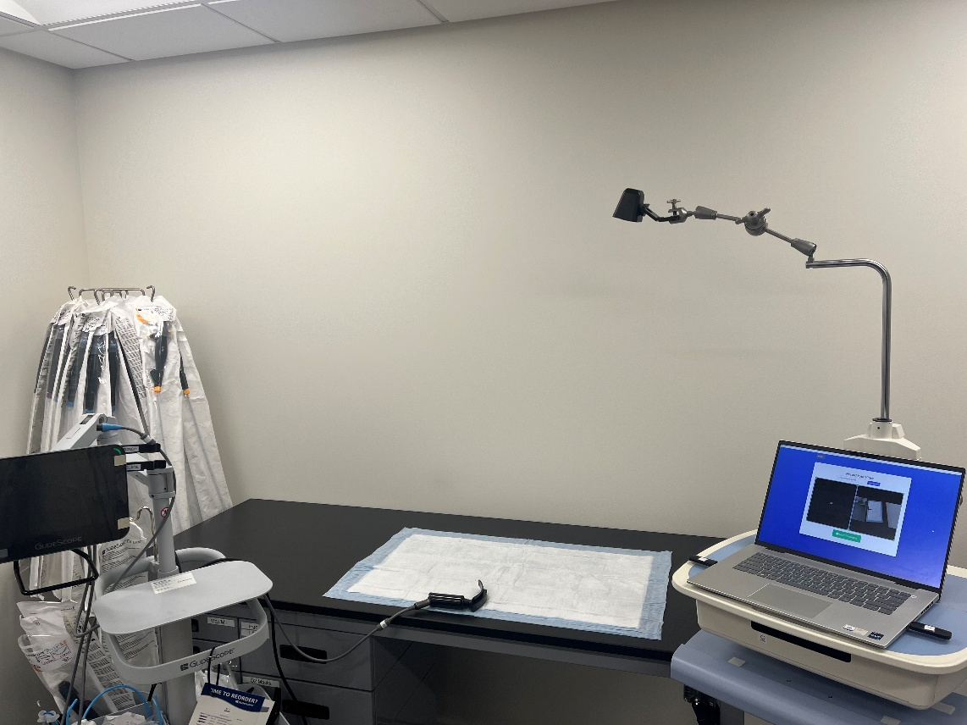

Airway procedures with GlideScope camera setup

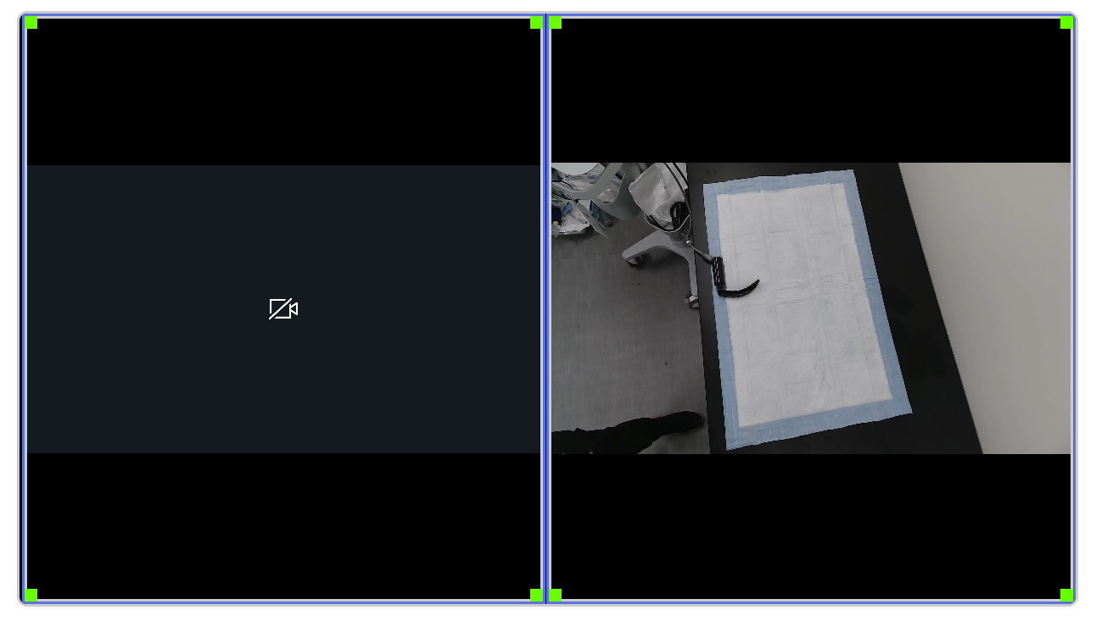

Overhead webcam

GlideScope camera

Airway procedures with GlideScope camera stream orientations

**Airway procedures without GlideScope**

* Oropharyngeal airway without GlideScope
* BVM
* Intubation
* Intubation verification
* Oxygen delivery
* NIPPV (CPAP and BiPAP)
* Nasogastric tube

Recording cart

POV webcam

Overhead webcam

Workspace

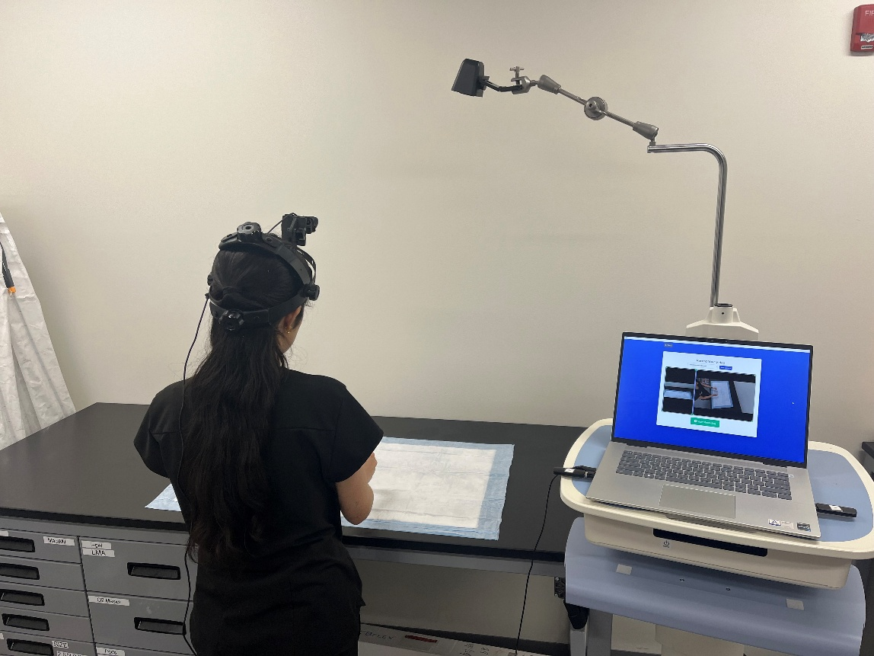

Airway procedures without GlideScope camera setup

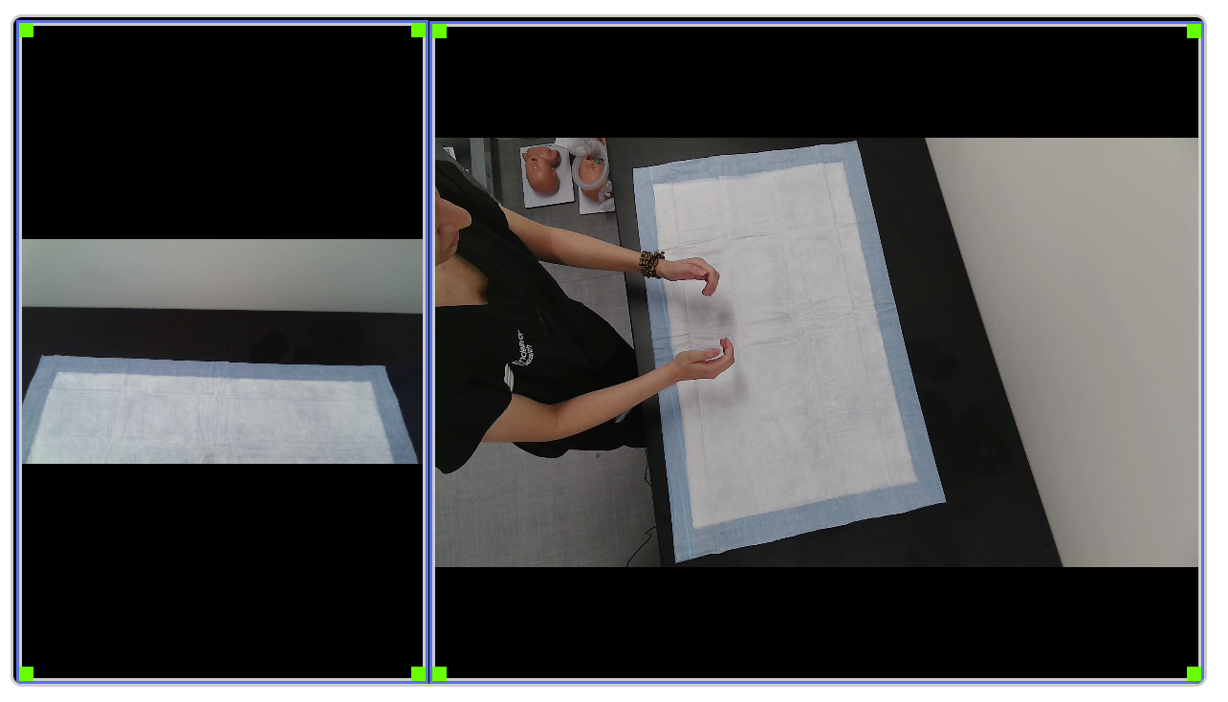

POV webcam

Overhead webcam

Airway procedures without GlideScope camera stream orientations

**Small area procedures with US**

* Arterial line placement
* Central line
* Pericardiocentesis
* Thoracentesis

US screen record

POV webcam

Overhead webcam

Recording cart

Ultrasound

Workspace

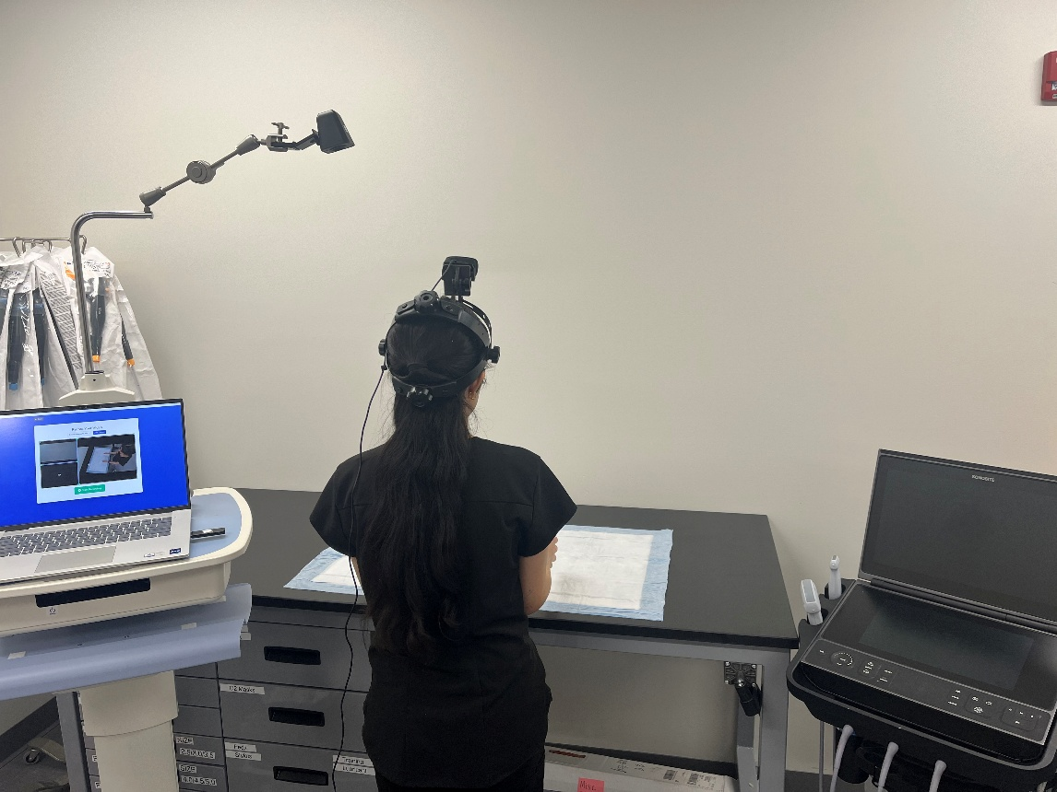

Small area procedures with US camera setup

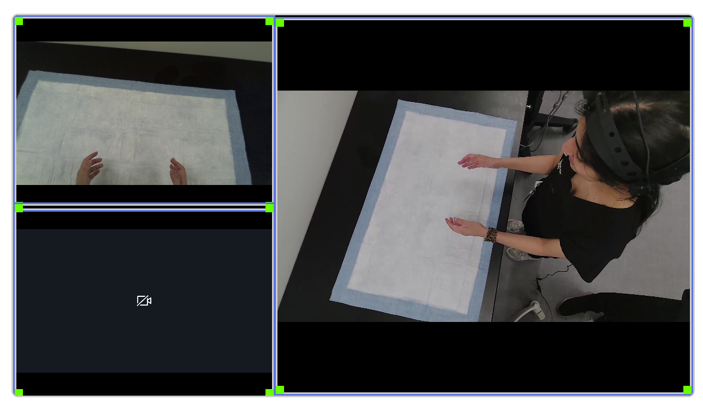

US screen record

Overhead webcam

POV webcam

Small area procedures with US camera stream orientations

**Small area procedures without US (category 1)**

* Intraosseous insertion
* Knee arthrocentesis
* Needle thoracostomy
* Incision and drainage
* Paraphimosis
* Saphenous vein cutdown

Low-angle webcam

Overhead webcam

Recording cart

Workspace

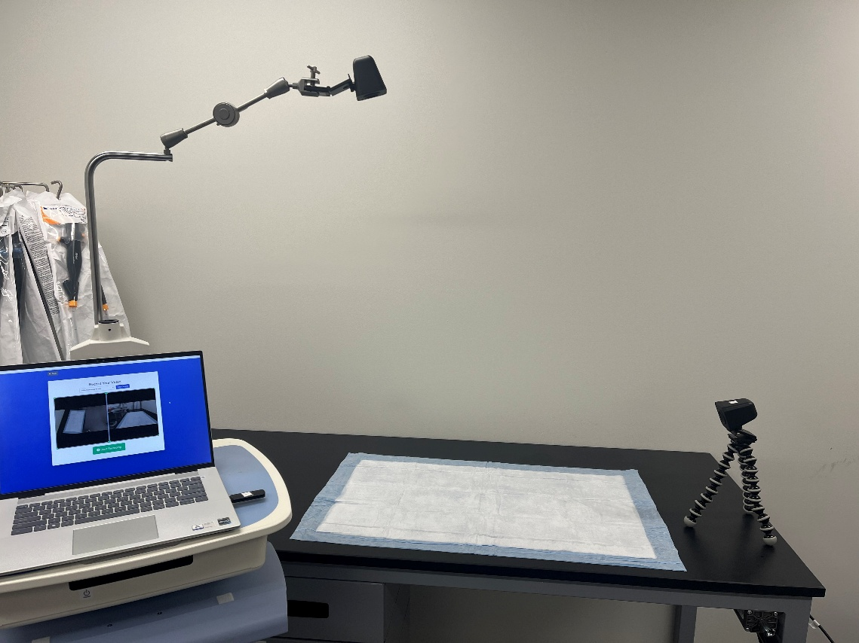

Small area procedures without US (category 1) camera setup

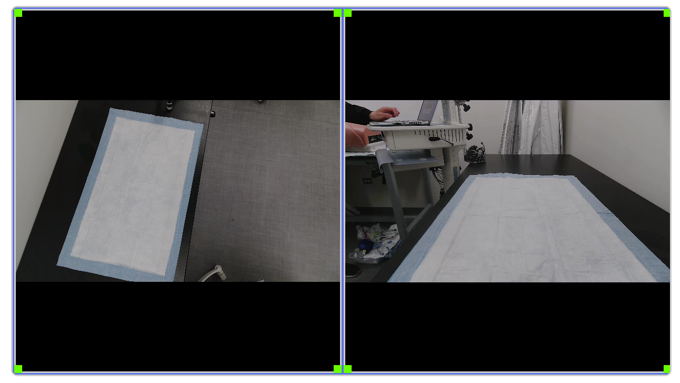

Low-angle webcam

Overhead webcam

Small area procedures without US (category 1) camera stream orientations

**Small area procedures without US (category 2)**

* Pacemaker (transvenous)

Low-angle webcam

POV webcam

Overhead webcam

Recording cart

Pacing laptop

Workspace

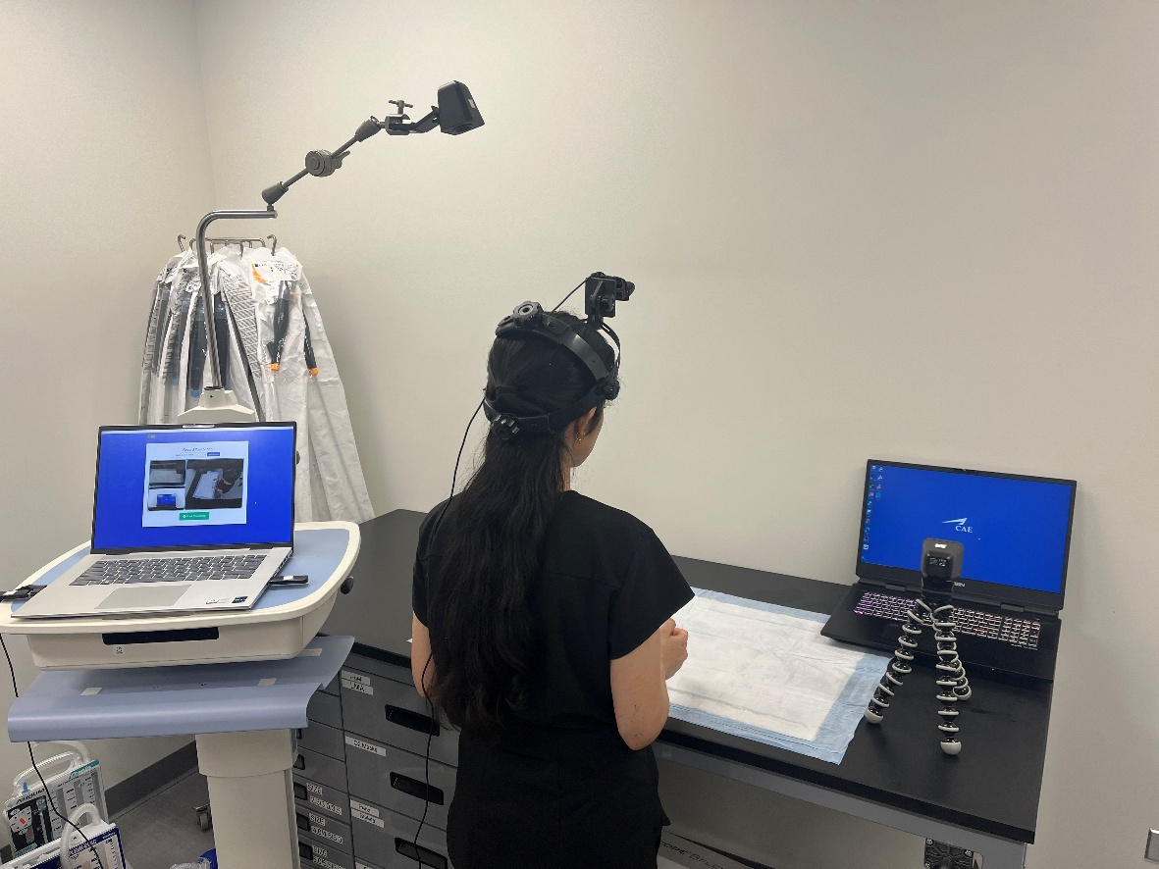

Small area procedures without US (category 2) camera setup

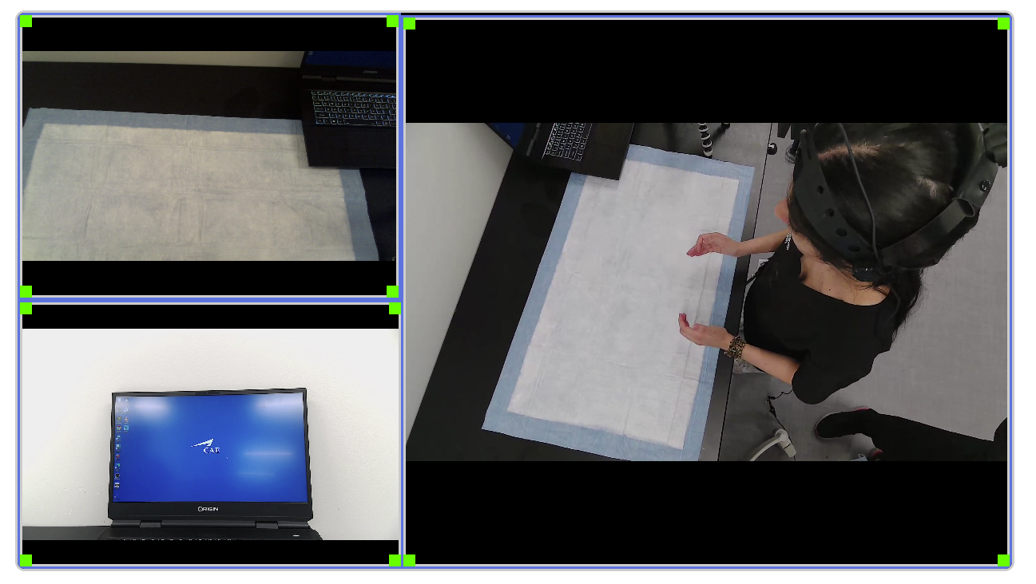

Low-angle webcam

POV webcam

Overhead webcam

Small area procedures without US (category 2) camera stream orientations

**Large area procedures without US (category 1)**

* Defibrillation and cardioversion
* Transcutaneous pacing

Low-angle webcam

Overhead webcam

Recording cart

Defibrillator

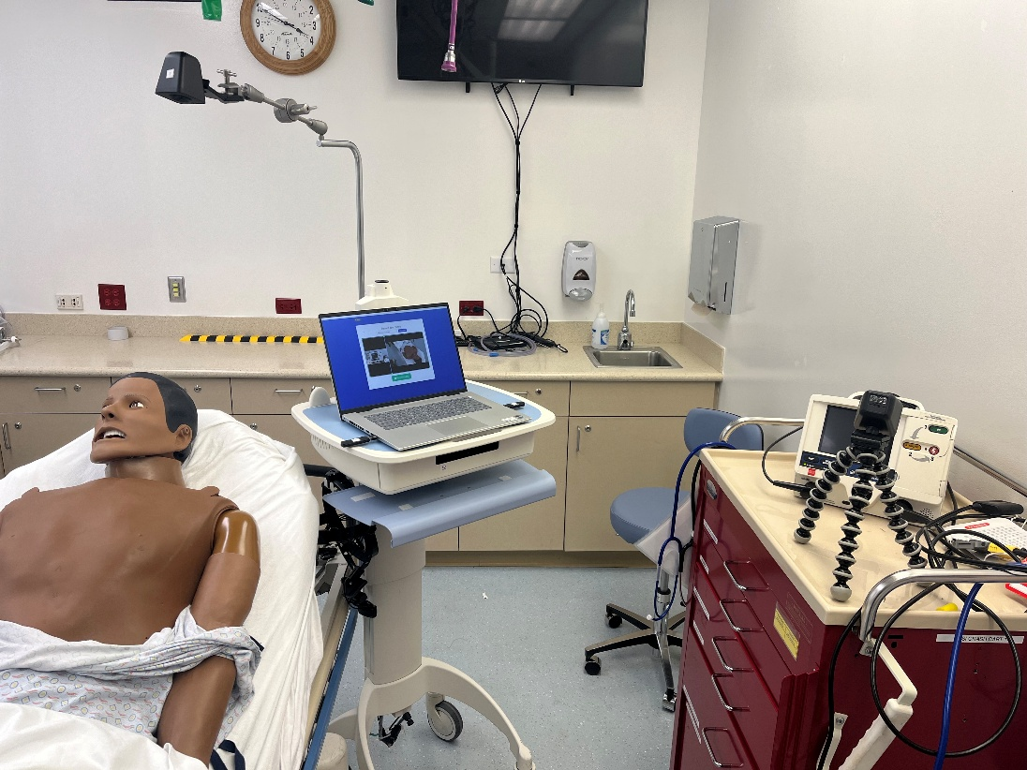

Large area procedures without US (category 1) camera setup

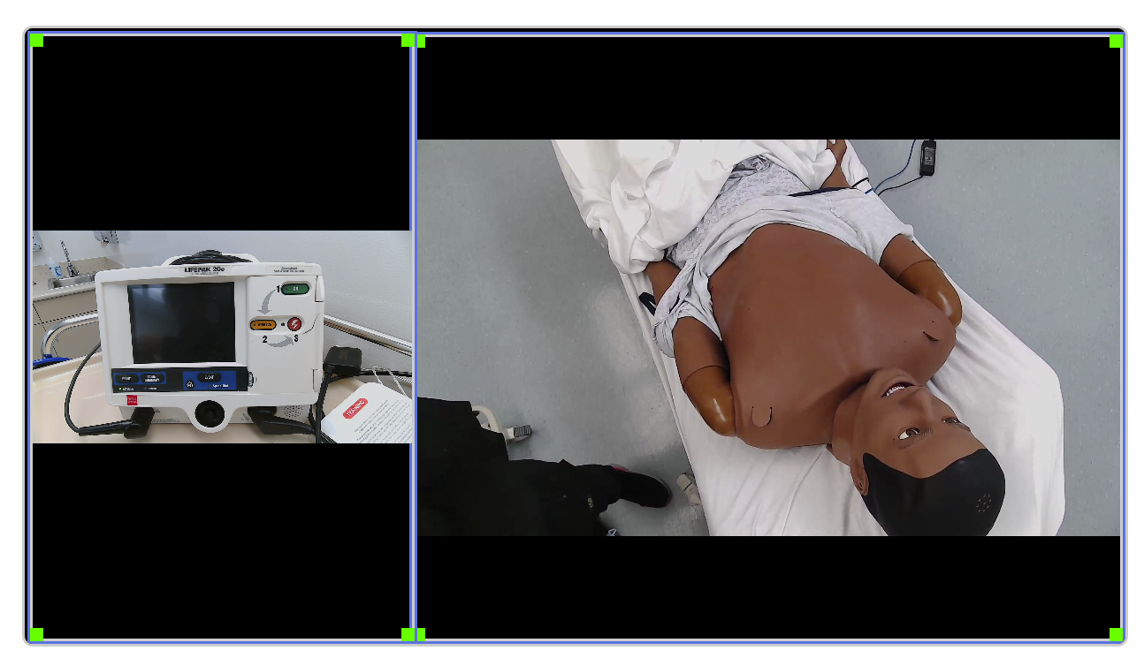

Low-angle webcam

Overhead webcam

Large area procedures without US (category 1) camera stream orientations

**Large area procedures without US (category 2)**

* Anterior epistaxis
* Tube thoracostomy
* Pigtail

Low-angle webcam

POV webcam

Overhead webcam

Recording cart

Workspace

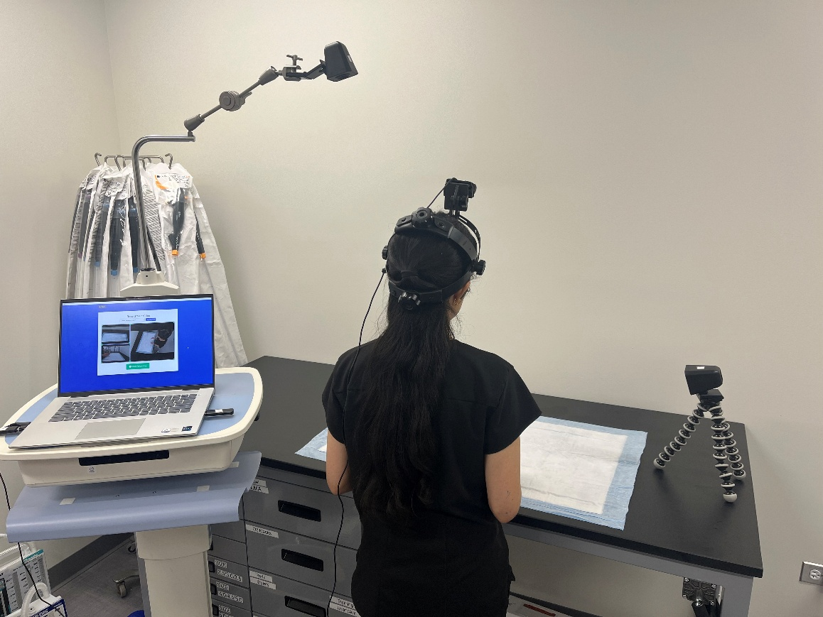

Large area procedures without US (category 2) camera setup

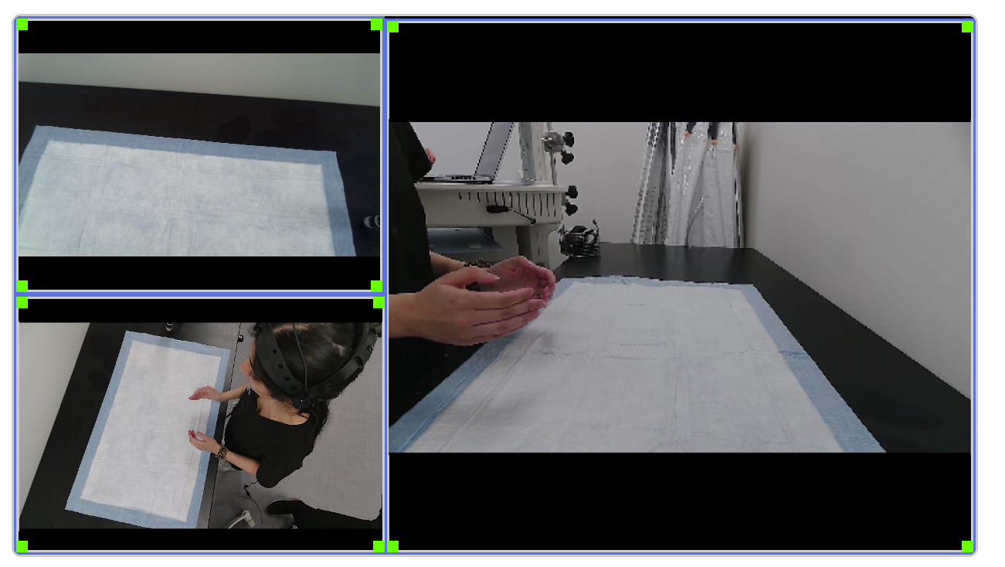

Overhead webcam

POV webcam

Low-angle webcam

Large area procedures without US (category 2) camera stream orientations